**Store Management Application using Collection**

1. Add Products in collection
2. View All products in collection
3. Search Product from collection
4. Delete Product from collection
5. Count total number of products from collection
6. Create Customer collection
7. Maintain purchase order of customer
8. View individual custom orders
9. View all customer reports
10. Delete customer and its order
11. Update customer orders

**Product Model**

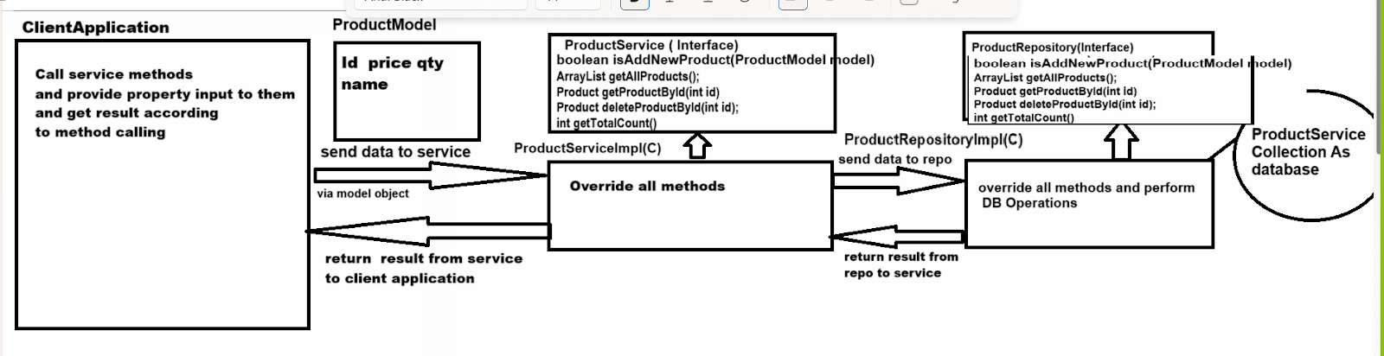

**public boolean isAddNewProduct(ProductModel):** this method can accept product model class and store in database i.e in collection

**Logic need to implement we add new products**

_______________________________________________________

1. Product id should not duplicate
2. Product name should not be blank
3. Quantity must be know means quantity should not zero and price also should not zero

**public ArrayList getAllProducts()**: this method can return all products from database but if product not found in database then system should generate user define exceptions product not found

**public Product getProductById(int id) :** this method accept id from keyboard and return product data if id not found then generate user exception name as product not found exception

**public Product deleteProductById(int id) :** this method can accepted from keyboard and return product data and if id not found then return product not found exception

**int getTotalCount():** this method can return total count of products



